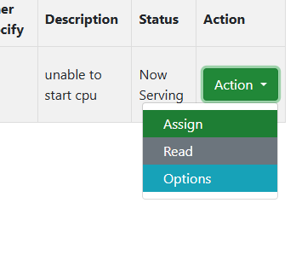
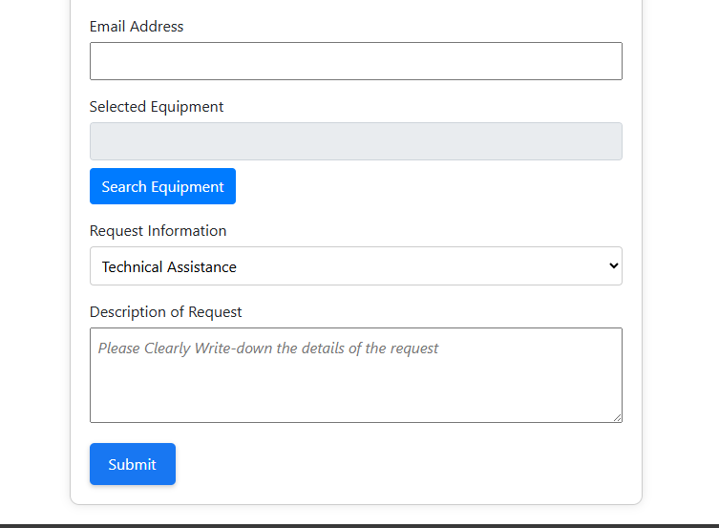
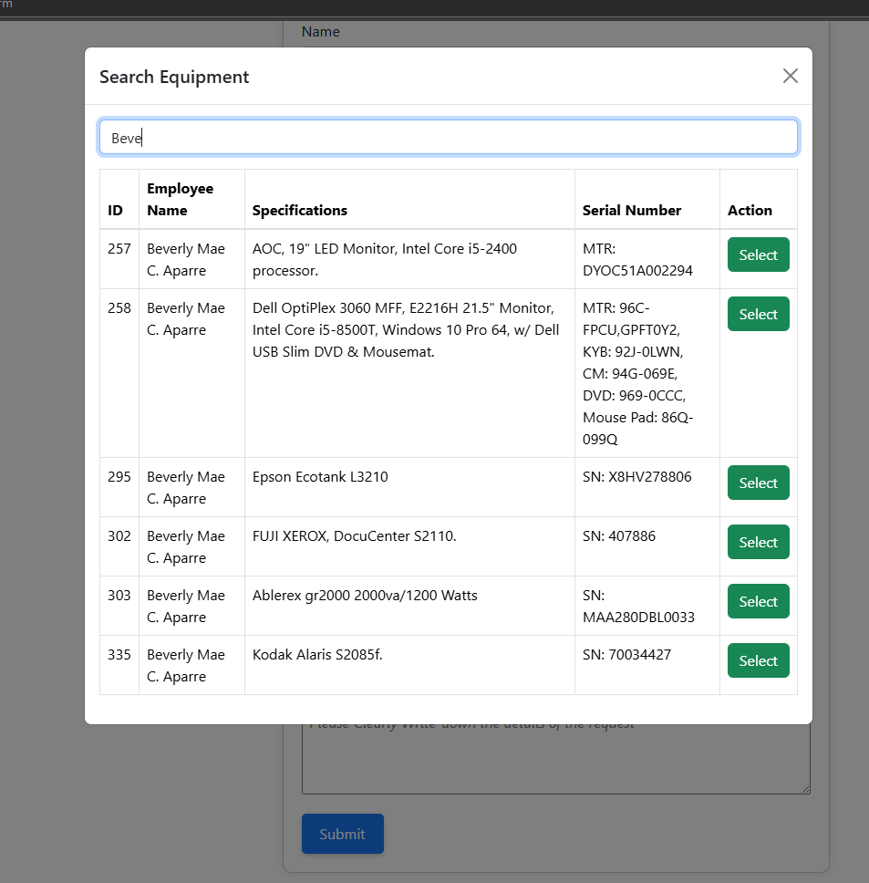
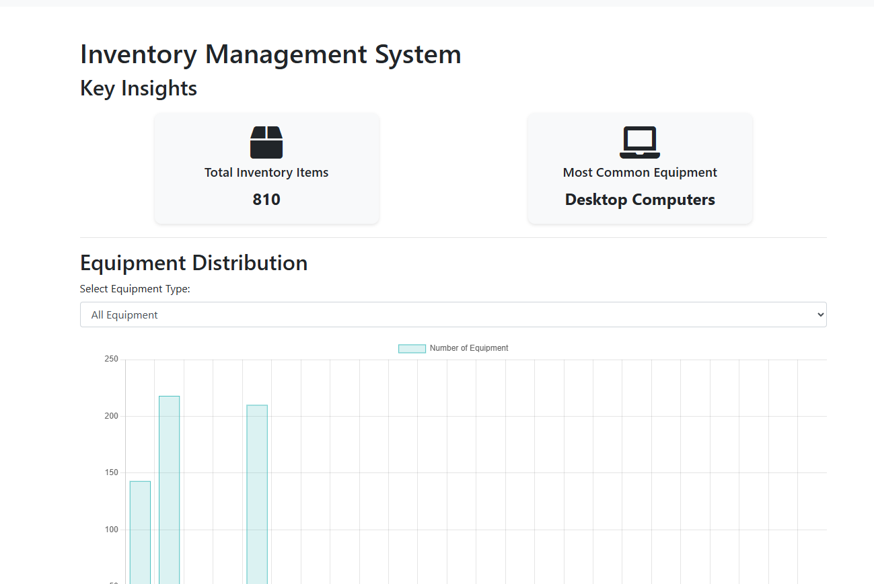
DIVISION CHIEF >BUTTON “ACCEPT” CHANGE TO “APPROVE”
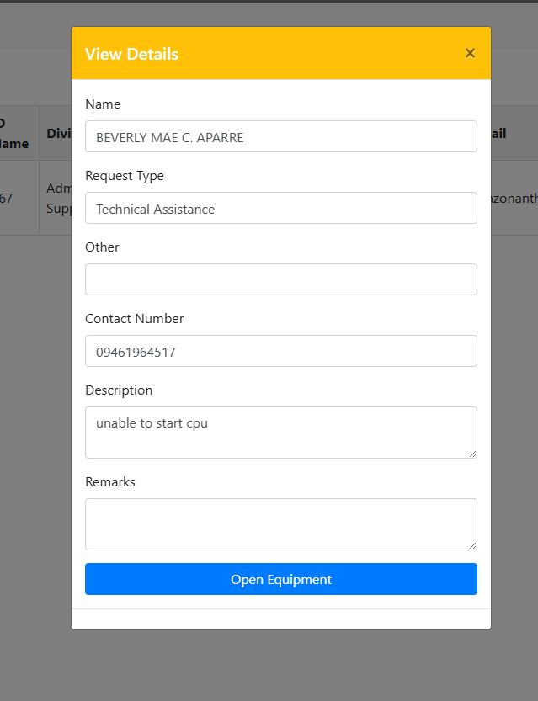
Change View Details
Change to Approved and Forwarded to RICTU – Kate
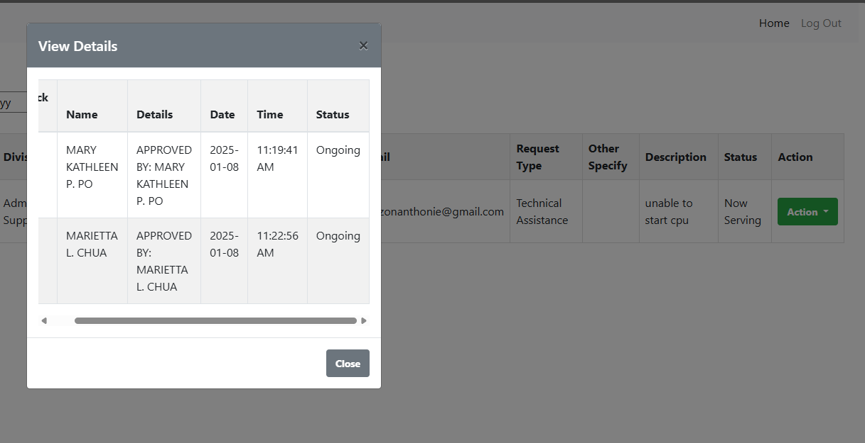
Assigned to CLEOVIN SILONG (varies) – Chief RICTU
Chief RICTU – Change to Receive
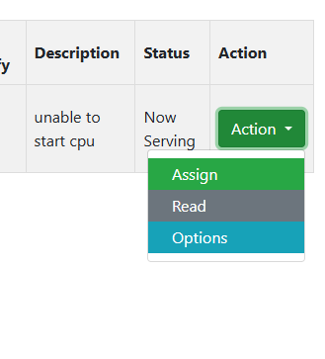
Cleovin Silong (varies) – (Add) Accept (Email – to Notify) (system-dashboard notification),
Message Echo
“Please bring the Equipment/Device/Unit to the RICTU Helpdesk.”
add notification
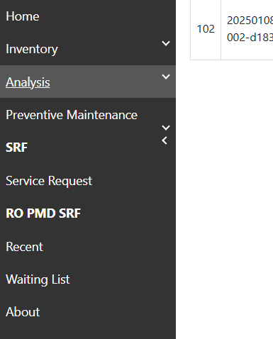
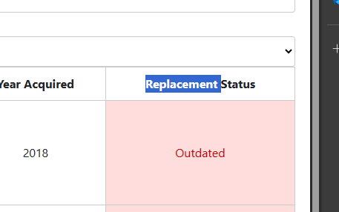
Replacement Status Change to Equipment Condition
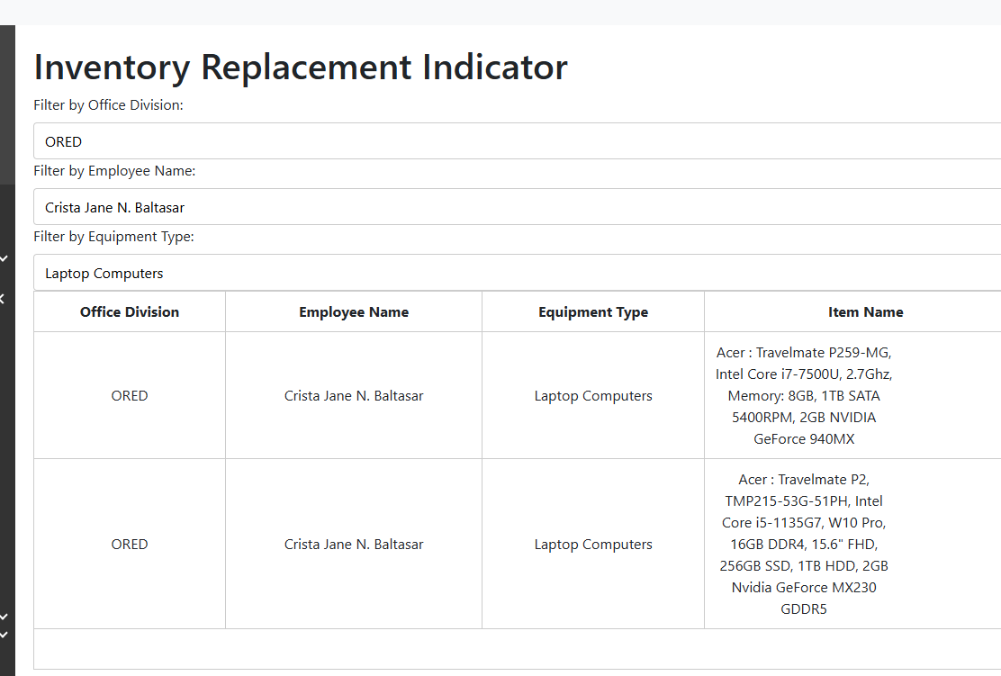
Inventory Replacement Indicator change to Equipment /Device Condition
Priority List of ICT Equiment for Replacement : Desktop , Lap
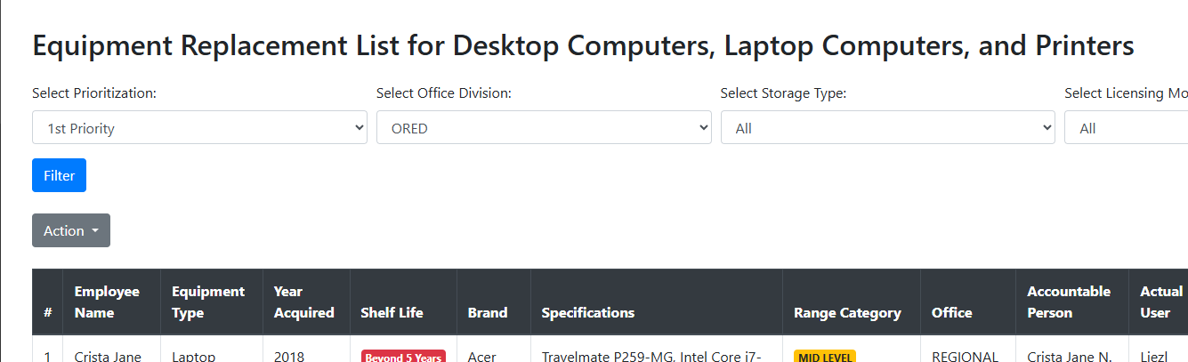
Add dropdown Desktop, Laptop,
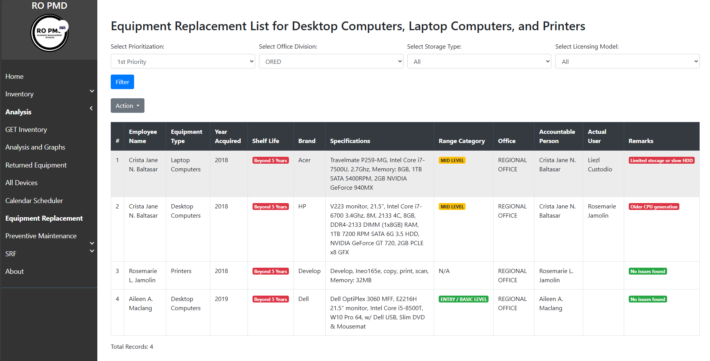
Identify the Prioritization 10 Is to 5 (Identify repair, preventive maintenance) Coding
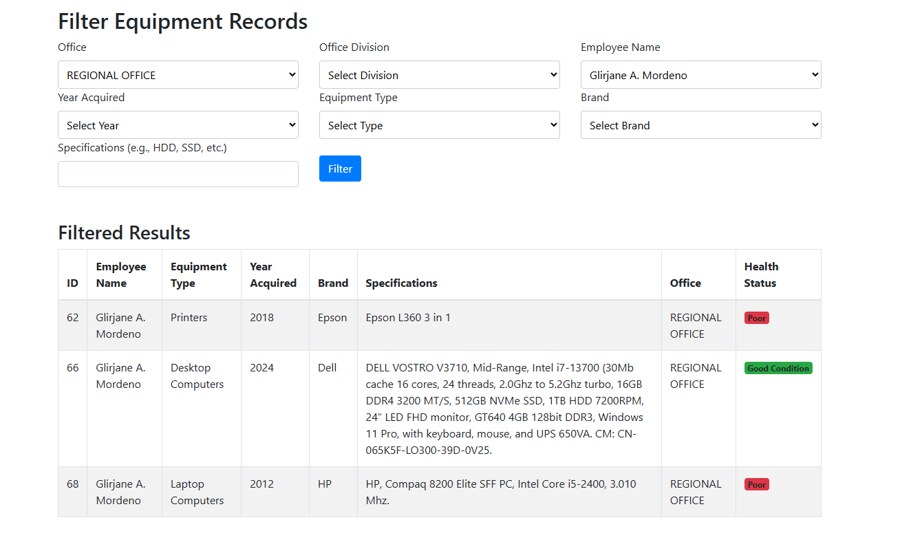
Add actual user (Colums) and Amount
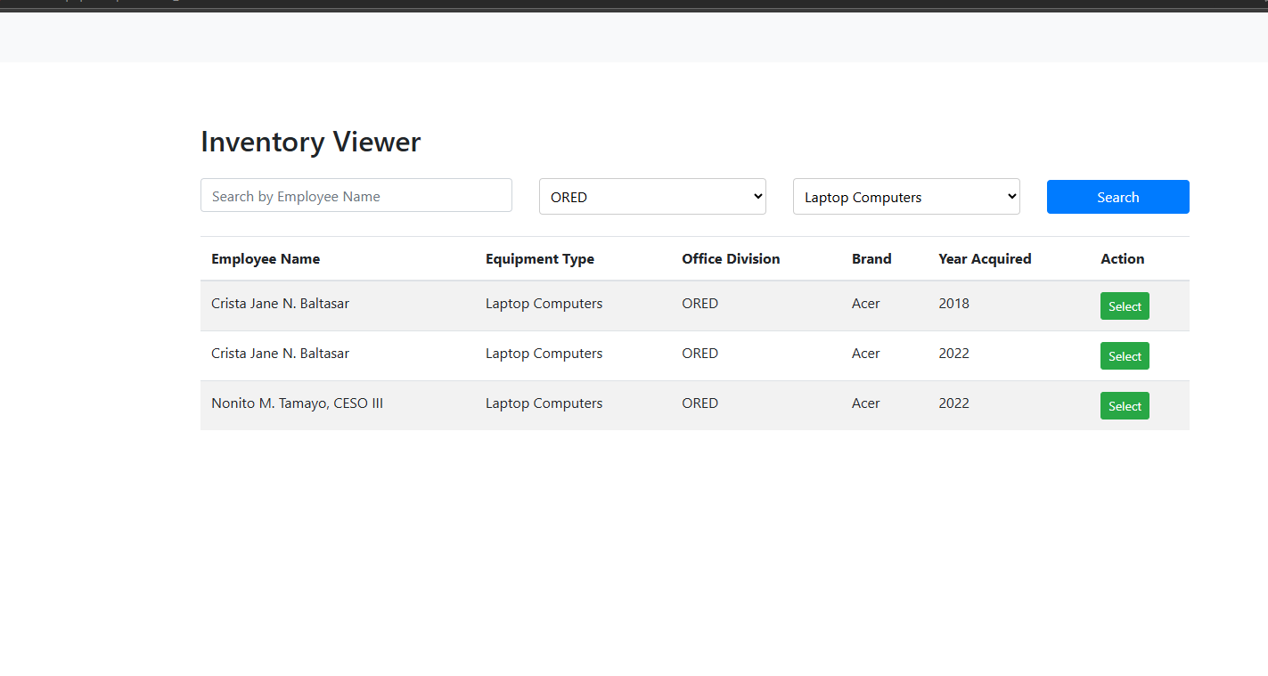
Add Option as one Desktop/Laptop
Colums (Property Number)
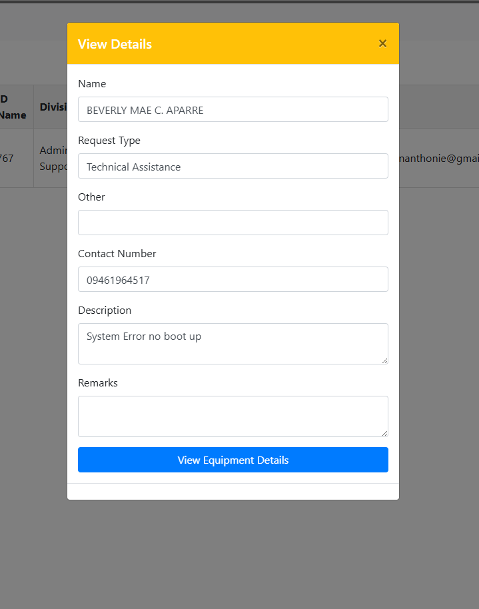
Replace to Actual Form
modal
if overlap set overflow to auto , set max height of modal
SRF FORM ADD ATTACHED FILE FOR SCREENSHOTS
ADD CHECKBOX-COMPLETED
ADD (REF: NIMD Request Form 22 March 2021)
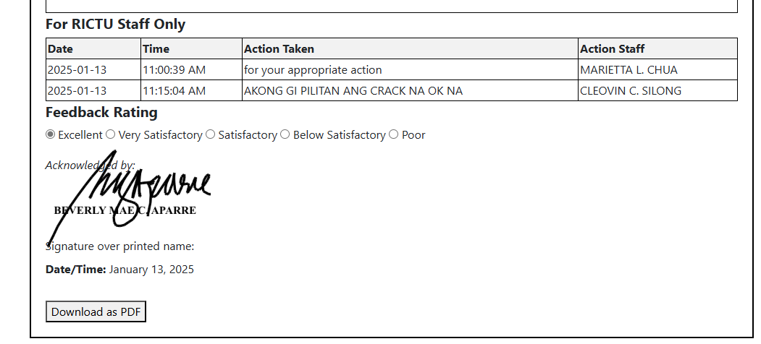
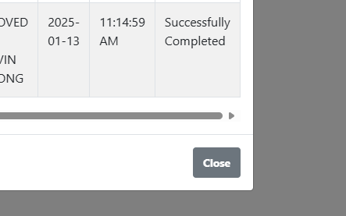
change to “Completed” add “action remarks”
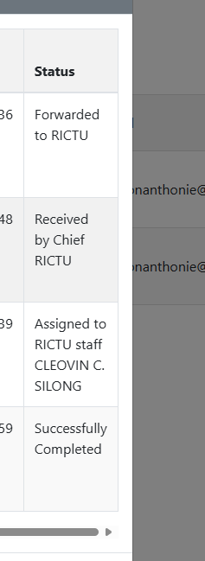
Add Remarks for Findings
IF FOR REPLACEMENT WAITING FOR SPAREPARTS IF AVAILABLE
add attachment
Change the font size to normal size-Chief RICTU
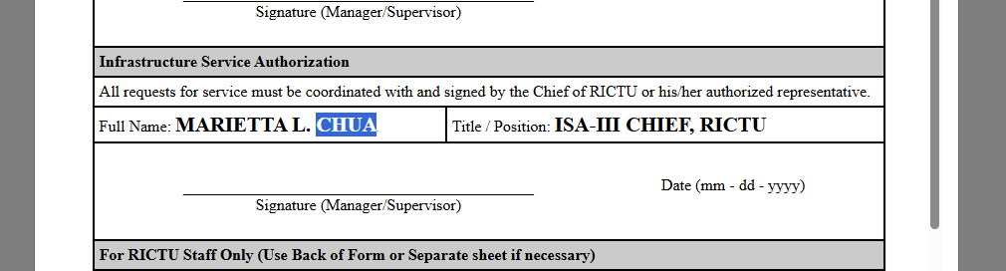
Change the “Read” to View Details and REMOVE the “Details”
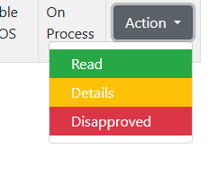
Add “Disapprove Button” and Remove the CLOSE button
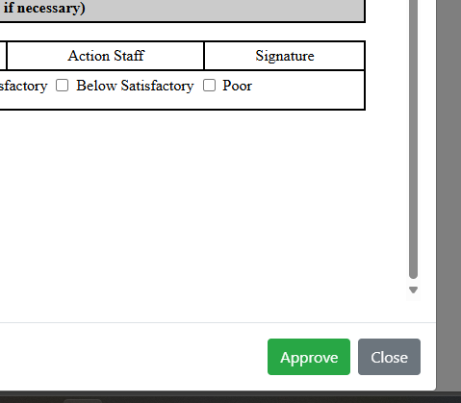

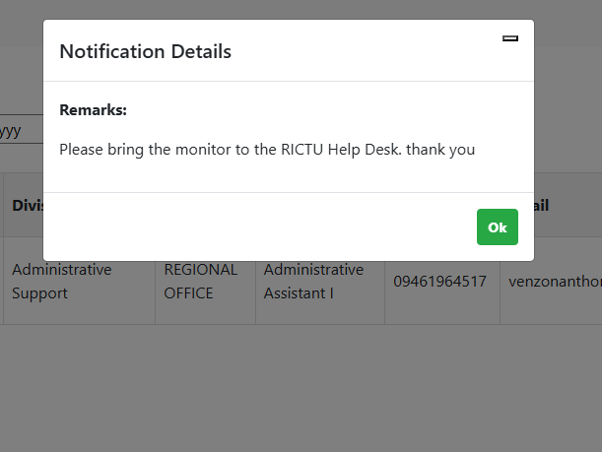
Nabali ang time sa Receive ug ang pag approve ni maam kate
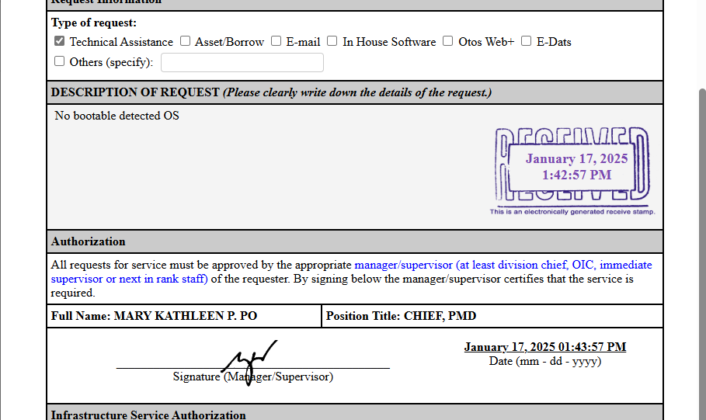
ADD INTERACTIVE NOTIFICATION “CHANGE OK” TO “REPLY”
Note: The turnaround time (TAT) for technical assistance shall commence upon receipt of the physical ICT equipment or spare parts.
Change the message into

Dear [Recipient's Name],

We are pleased to inform you that your service request, with Ticket Number [Insert Ticket Number], has been successfully processed. You may now proceed to the RICTU Help Desk for any items or updates related to your request. Thank you for your cooperation and trust in our services. Should you need further assistance or have additional requests, please feel free to contact us.

Best regards,
RICTU Team
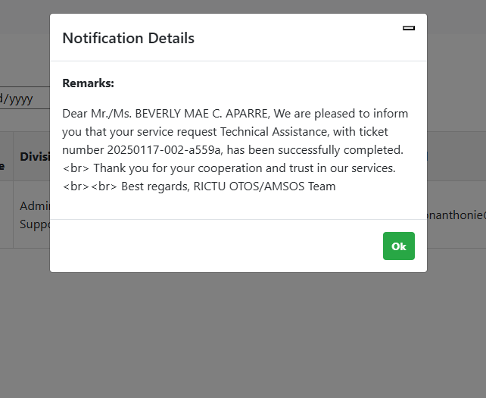
Change button “Acknowledge” >
Remove “Successfully”
